DIS-AM,C-Taino-Itiba Cahubaba

This is an extremely rare and important sculpture of *Itiba Cahubaba*.

*Itiba Cahubaba*, “Great Bleeding Mother,” is a primary ancestor spirit among Taino deities called *cemís* (zemís). *Itiba Cahubaba* dies in childbirth, begetting quadruplets, symbols of the four cardinal points and the four elements: fire, water, air and earth involved in the myth of Yaya and his son Yayael that gave rise to the human species.

Identified by Caribbean scholar José Juan Arrom, Itiba Cahubaba is notable for her eyes, indicative of Taíno depictions of deities. Itiba’s emaciated arms, always folded over her bulging belly, represent the suffering of her creation. Cosmic navigator, Itiba Cahubaba wears a headdress with four trapezoid incisions that appear to depict the Caribbean winter (short) and summer (long) solstices. According to Arrom, the curvature of her cap informs Taíno navigation.

In Cuba, Itiba Cahubaba is associated with pregnancy, labor, delivery, and—among the people of the eastern mountains—the Virgen de la Caridad del Cobre, the matron saint of the island. Many pregnant and post-natal women attend the Virgen’s shrine in supplication and thanks. Taíno descendants from the Sagua–Baracoa Mountains still make offerings and burn tobacco for the Mother Earth spirit and attribute the success of their crops and the potency of their traditional herbal medicines to her benevolence.1 The names of Caribbean Taíno cosmological personalities also continue to figure in the toponymy of the islands. There is a historic Río Cahobabo and a nearby village Playitas de Cahobabo in the easternmost part of Cuba. The local population from the region of Cahobabo sustains many Native herbal and culinary traditions.

the first woman to give birth and the ancestress of all humanity,

Recorded in a Taíno myth recorded ca. 1496 by Catalan Spanish Jeronymite Priest Ramón Pané.

Pané (chapters IX-X), and this sculpture explicates aspects of the myth:

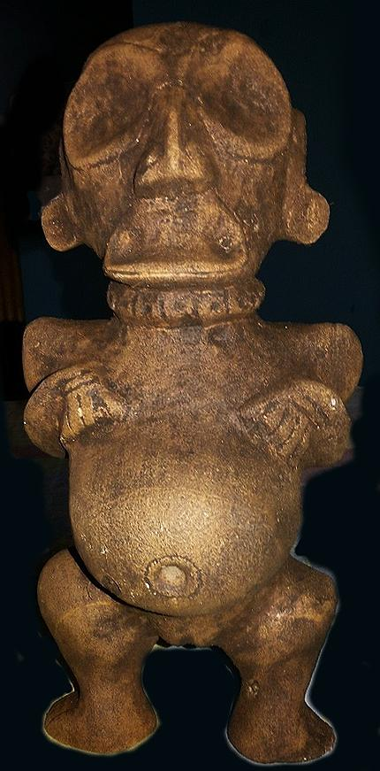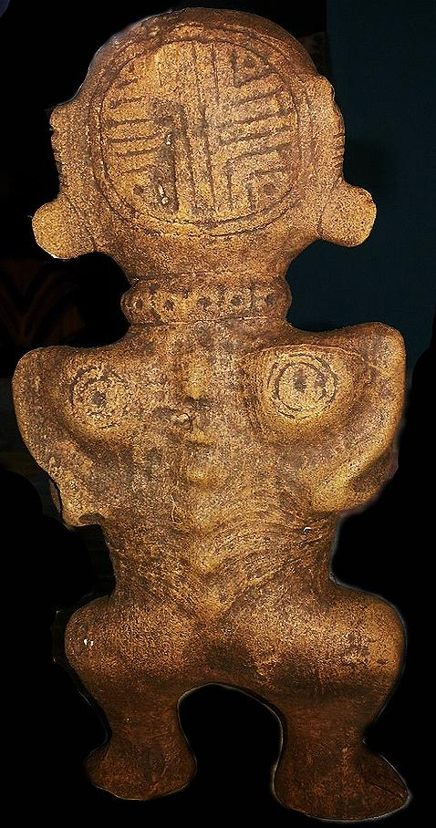

**First.[1]**

This sculpture provides visual representation of the anguish of *Itiba Cahubaba* in the last stages of pregnancy prior to her fate of dying in childbirth. Her mouth is in a grimace, and her spine is showing through her skin suggesting emaciation.

**Second.**

This sculpture provides visual representation of the placement of a surgical incision drawn 3-4 inches above her navel prior to the caesarean section that successfully resulted in the delivery of her quadruplets, four male children.

**Third.**

This sculpture invokes the Tainó world-view as a mixture of black as well as white, capacious enough to hold opposites in tension. Therefore, Tainós invoked opposites as dualities not as dichotomies in their world-view.

They could interpret the number “four” as fertility and as the inverse of fertility. Indeed, *Itiba Cahubaba* had to die to bring forth life.

In another myth Yayael, the son of Yaya, a mythical cacique, was banished from his home island. He was commanded to seek a new home elsewhere. However, he broke this commandment and returned after 4 months only to be ritually executed by his father for not heeding his father’s sentence of total banishment. Among island people the carrying capacity of the island was of paramount importance to a cacique and the people over whom he was designated to protect, and banishment was one way to address the problem of over-fertility that could outstrip an island’s necessarily limited natural resources and put everyone at risk.

The moral of these exempla was that human over-fertility could disrupt the carrying capacity of an island and hence could be a real danger to the whole community, as in the case of *Itiba Cahubaba’s* quadruplets. The births were not only a blessing, but, also, conversely, a curse, for it imperiled the Tainó idea of “sexuality in the service of the community” and, from this perspective, over-fertility was a goal *not* to be emulated.

The consequence of over-fertility is seen in *Itiba Cahubaba’s* facial grimace, and it places the spiritual teaching of limiting human fertility squarely on the shoulders of the shaman. This teaching is at odds with 16th through 21st century Roman Catholicism and 19th through 21st century Southern Baptist Convention that view the virtue in having the most progeny biologically possible as a spiritual goal since the most progeny will populate the planet with progeny replicating the saved parents. As one spokes-*man* of the converse of this doctrine in its 19st century Southern Baptist rendition has put it, the Church (curiously in line with both Baptists and Roman Catholics) “views pro-generation among parishioners prior to being verified as both saved partners “ issue their progeny from a “virus of sin from a poisoned fountain” (Russell: ). Unless both ***heterosexual*** [my italics] partners are religiously deemed “saved” prior to conception in the womb, the Roman Catholic Church and the Baptist Church of the American Southern Convention doctrines stipulate that couples (engaged in the sex-act prior to their both being saved) are both damned to eternity.

As a student of modern 21st century theology, biology and virology, this writer finds this interpretation of 21st century virology of sexual transmission unacceptable. It indicates a refusal on the part of the 21st century theologians, Roman Catholic or American Baptist Southern Convention, of understanding what constitutes a connection between the profound viral and spiritual impacts on virologic hosts. It is a continuation of a medieval thought form of St. Thomas Aquinas from the 13th century into a 21st century mode that makes it all the more virulent among “the modern unlearned” who claim to be biologically attuned to what is consumed by the human host, and spiritually attuned to meditation practices but without having any professional knowledge of metabolic biology or comparative theology. It is akin to denying anthropogenic causes of global warming by refusing to use the data of the GISP because it is too technical.

Numerological symbolism is also invoked on the back of *Itiba Cahubaba’s* head with a “body stamp” that is also found on the bases of frog *cemis*. The “body stamp” that is on the back of *Itiba Cahubaba’s* head has four quadrants, and it is suggested that each quadrant represents one of her progeny. Until now this connection of *Itiba Cahubaba’s* quadruplets has not been connected with the significance of the quadripartite body-stamp symbolism of frog *cemis*.

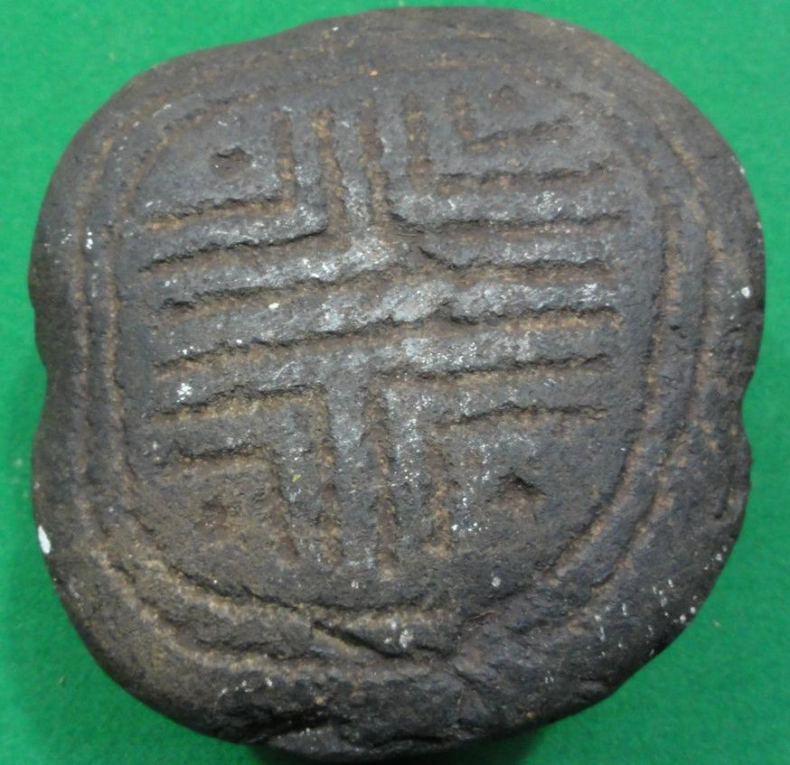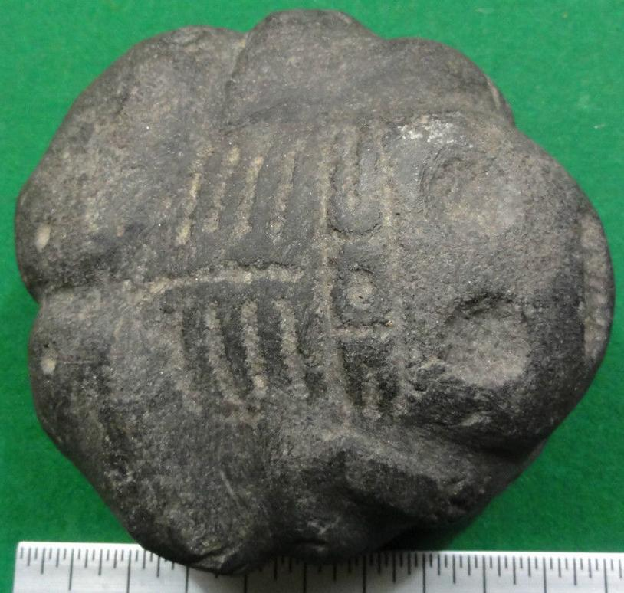

Taino Frog Body-stamp Cemi. Atlantika collection

However, the frog is a well-known Tainó symbol of fertility, and women were thought to become especially fertile when frogs emerged from tadpoles. Here, in this sculpture, we have evidence of the connection between *Itiba Cahubaba* and frog symbolism. Since the emergence of the frog from tadpoles occurred only once a year, the myth could have the effect of proscribing successful human fertilization to once a year. If this hypothesis is correct, then it is possible that shamans in the instruction of male and female youth’s puberty rites may have given some kind of birth control to both sexes.

This hypothesis is supported by the fact that that shamans gave instruction to pubescent girls in unlocking sexual experience by using puberty rite stones in the shape of circumcised penises to rupture the hymen (Olsen 1974: 348). The exact shape of the puberty rite stone also indicates that it involved the cutting of the foreskin. Therefore, both puberty rites involved uninitiated youth in a spiritually consented, common ritual that was sealed in blood by shamans in the service of the whole community, in order to protect future generations from over-populating their precious, limited insular resources. This spiritual-sexual practice aligned human fertility and its associated liquid component, blood, with the fertility of the land and its liquid component, rain, and the liquid component of rivers and the sea, water, with the fertility of the island’s natural resources.

The Tainó were sophisticated logicians and mythmakers. They were especially adept at invoking pairs of dualities to suggest a capacious world-view that could see the objective reality of a world composed of a mixture, not a dichotomy, of opposites: black melded into white, death melded into fertility, evil melded into goodness, etc., all of which permeated a melded world. The opposite of this melded world-view interpreted sin as the opposite of salvation, the devil as the opposite of the savior, and the priestly Roman Catholic ecclesiastical hierarchy as the only earthly mediators of the only savior. This Roman Catholic world-view preliminarily disallowed the role of Tainó shamans as spiritual mediators by the Roman Catholic Spaniards under Columbus’s command, since Tainó shamans were seen as in league with the devil. Consequently, Columbus and his men felt justified in treating the Tainós brutally as brutes, to the extent that by the end of the 16th century there were no pure-blood Tainós left but plenty of mestizos, the result of wanton rape by the Spaniards.

**Fourth,** the sculpture of *Itiba Cahubaba* is the ancestress of humanity indicated by the symbolism of her encircled navel that shows that she is the Taino symbol of life itself. Also her two shoulder blades are similarly inscribed, probably as tattoos, with a center point and two concentric circles, also symbols of life. Perhaps, these concentric circle “tattoos’ were a response to keeping the Tainó free from the Christian devil symbolized by the omnipresent cross.

# Olsen,

# **Russell, Charles T. 1916 [reprinted 2000]. The Divine Plan of the Ages.**

1. In the descriptions that follow, the grammatically correct adverbial descriptors ending in “ly” are not used. Instead the incorrect 21st century English speech *patois* using an adjectival modifier (which is grammatically incorrect) is used instead of an adverbial modifier. For instance, the adjectival modifier “first” is used instead of “firstly.”